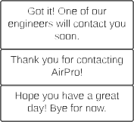

Yes, please!

No, I am just browsing.

Okay, great! What is your email address? We will send you a transcript of our chat afterward.



No problem. Here's an article to help you know which fan types may be best for your application.

[Industrial Fan Types](https://airprofan.com/industrial-fan-types-energy-consumption-and-the-fan-static-efficiency-calculation/)

[Feel free to reach out if you have any question. You can email](https://airprofan.com/industrial-fan-types-energy-consumption-and-the-fan-static-efficiency-calculation/) [fans@airprofan.com](mailto:fans@airprofan.com) [or call 715-365-3267.](https://airprofan.com/industrial-fan-types-energy-consumption-and-the-fan-static-efficiency-calculation/)

User enter email

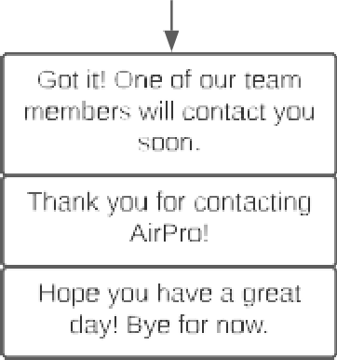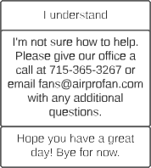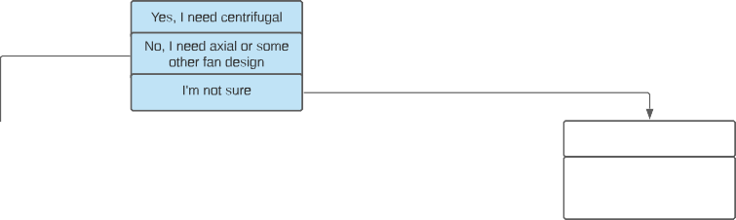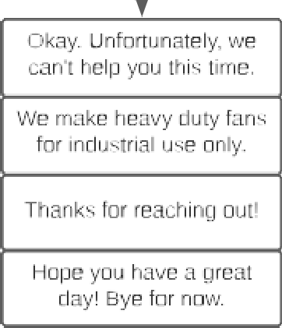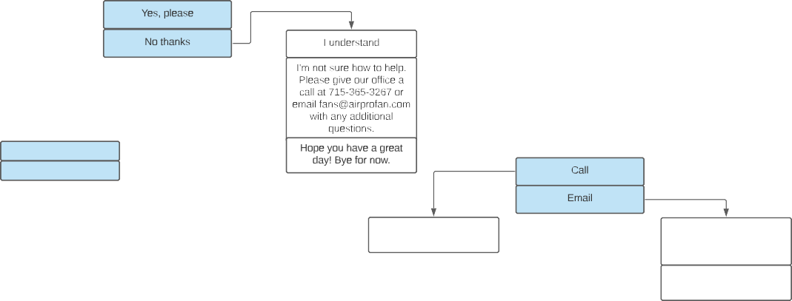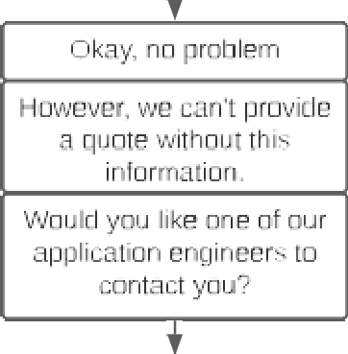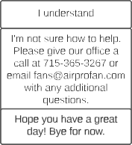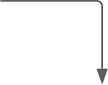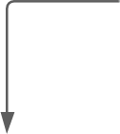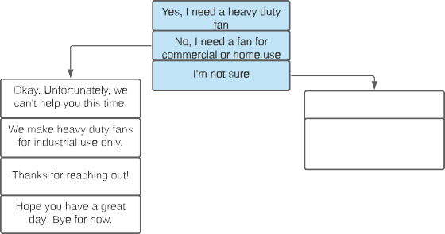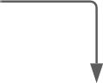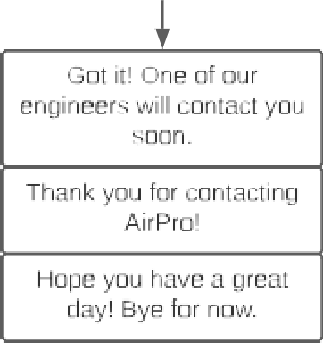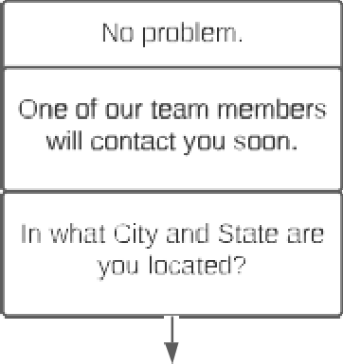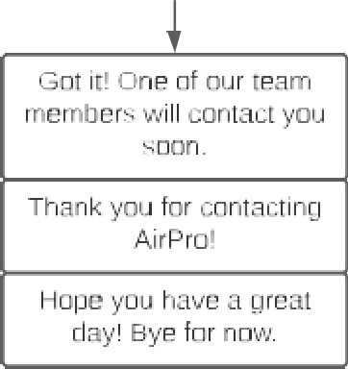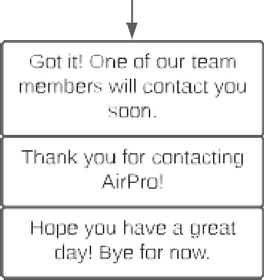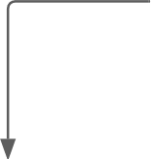

Thank you, #First Name! What would you like to do?

Buy a fan

Buy fan parts

Other

Got it!

Is your fan for industrial use?

Great, we can provide parts for both our fans and many other brands.

Do you need parts for an AirPro fan?

Okay, how can we help?

Enter information

Yes, please

No, a different fan brand

Okay, I'll get one of our team members involved

Fant

GOt It!

In what City and State are you located?

No problem.

Do you need a centrifugal or axial design?

Would you like one of our application engineers to contact you?

Do you know the fan serial number? Or part number?

Enter City

Yes Enter State

No

Love hearing that!

Centrifugal = our specialty.

No problem.

Great!

Enter serial and/or part number

Do you need more than one fan?

Would you like one of our application engineers to contact you?

Please provide your City and State.

What parts do you need?

Enter parts

Upload information

Enter City

Yes Enter State

Thanks, how soon do you need delivery?

Okay, one of our team members will contact you soon.

No

Great!

Thanks for that! We are almost finished.

Enter delivery date

Enter City

Enter State

Thanks, how soon do you need delivery?

In what City and State are you located?

Enter delivery date

Okay, great!

Please upload your fan specifications.

Sounds good

Please provide your

and State.

Do you prefer our engineer call or email you?

Thank you! Almost finished.

Do you know the fan's airflow and static pressure requirements?

Thank you! Almost finished.

Enter City

Enter State

Upload fan specs

Lastly, please provide your City and State.

Yes

Thanks for that! We are almost finished.

Thank you! Almost finished.

NO

Enter the fan's airflow

How soon do you need delivery?

Enter the fan's static pressure

Do you prefer our engineer call or email you?

Okay, what is your phone number?

Enter phone number

Thank you! One of our engineers will contact you soon.

Hopeyou haveagreat

day! Bye for now.

Enter City

Enter State

Call

Enter delivery date

Thank you, do you have any additional fan specs†

Email

Thank you! One of our engineers will contact you soon.

Okay. Lastly, please tell us your City and State.

Yes

NO

Okay, what is your phone number?

Hope you have a great day! Bye for now.

Enter phone number

Enter City

Enter State

Upload fan specs

Thank you! One of our engineers will contact you soon.

Hope you have a great day! Bye for now.

Thank you! Almost finished.

Thank you! One of our engineers will contact you soon.

Hope you have a great day! Bye for now.

Great!

Okay. Lastly, please tell us your City and State.

Please provide your City and State.

Enter City

Enter State

Enter City Enter State

Thanks for that! We are almost finished.

Do you prefer our engineer call or email you?

Hi, welcome to AirPro!

We offer the most reliable industrial fans in the USA.

Would you like me to assist you with a fan project?

Thank you for that. May I also have your name and company name please?

Enter 1st and last name

Enter company name



Okay, that's not a problem.

What fan parts do you need?

Enter parts

Are you able to upload any fan drawings, specs, or photos?

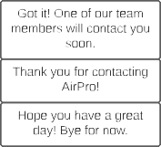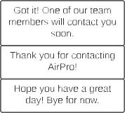

Enter City

Enter State



Lastly, please provide your City and State.

Enter City

Enter State

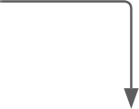

Call

Email

Okay, what is your phone number?

Enter phone number

Thank you! One of our engineers will contact you soon.

Hope you have a great day! Bye for now.

Thank you! One of our engineers will contact you soon.

Hope you have a great day! Bye for now.